# User Documentation

## System Overview

In this system there five tabs that shows deferent screens that can be used and they are

employee(that has the info of employees),

traveller(that shows info about travellers)

, bags owner(that shows the bags number and their owner number),

number of jobs(that gives the deferent jobs and the count of each employee that work that job),

traveller_phonenumber(that show the traveller identification number and their respective phonenumber),

and these tables gives the user access to specific data in the database and it gives him the ability to change the data if he has the privilege to do that, here are the what the user that is (Ahmad) in this case can do

-traveller (the user can add and edit and see or apply a filter to see specific info, and to delete the info of the travellers)

-bags owner (the user can see what is inside the page and apply a filter to see specific info to get specific results)

-number of jobs (the user can see what is inside the page and apply a filter to see specific info to get specific results)

-employee (the user can see what is inside the page and apply a filter to see specific info to get specific results, and he can edit only the job name of the employees)

- traveller_phonenumber (the user can see what is inside the page and apply a filter to see specific info to get specific results, and to add a new phone with his owner identification number)

## Using the system

**Note**: describe the system by its pages and functionalities per users. You need to add screenshots.

This is the beginning screen:

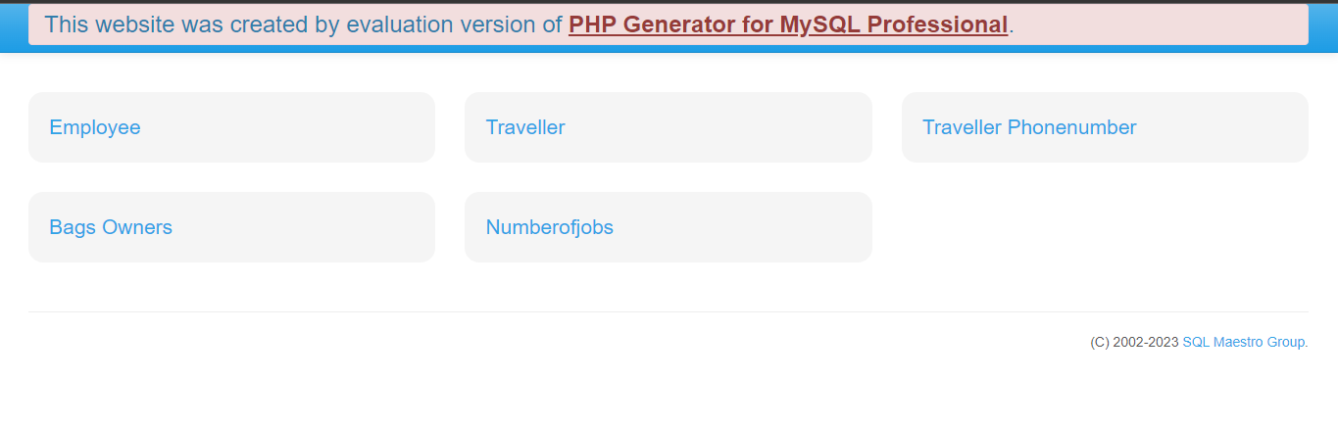

If you press on employee:  
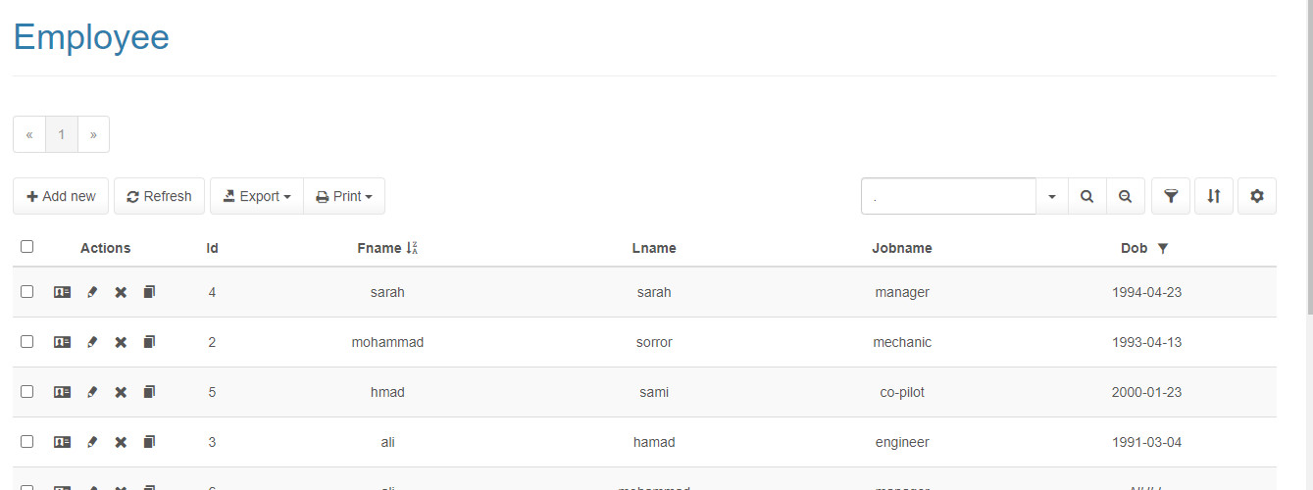

In this page you can the user can see what is inside the page and apply a filter to see specific info to get specific results, and he can edit only the job name of the employees

Here is how:  
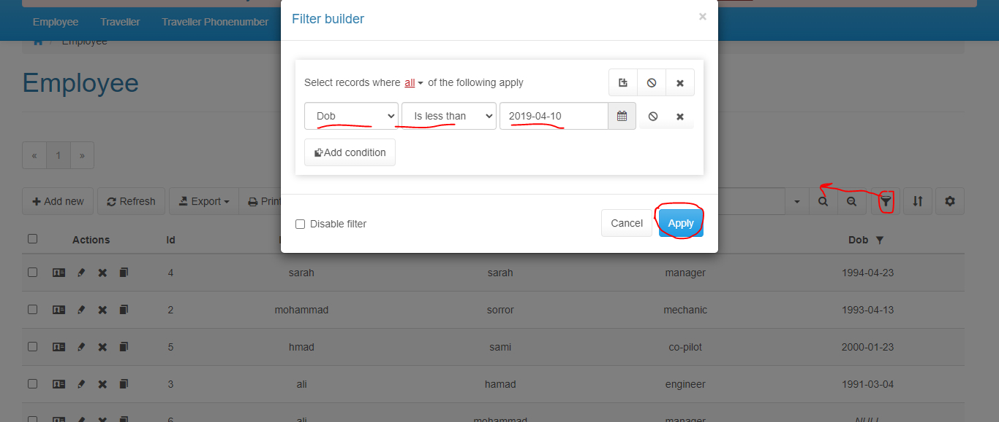

When applied the filter will work

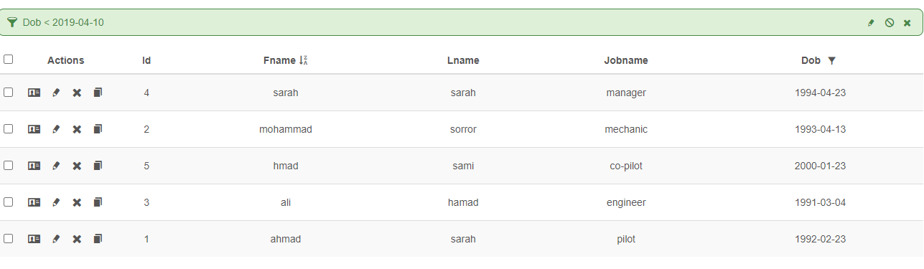

To edit the jobname:

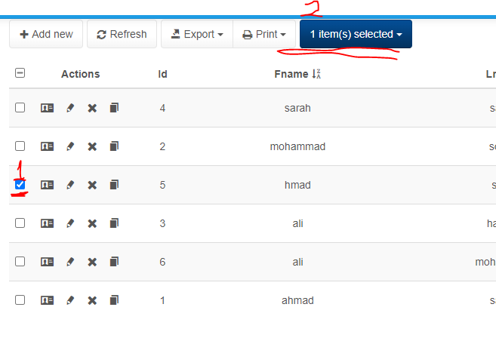

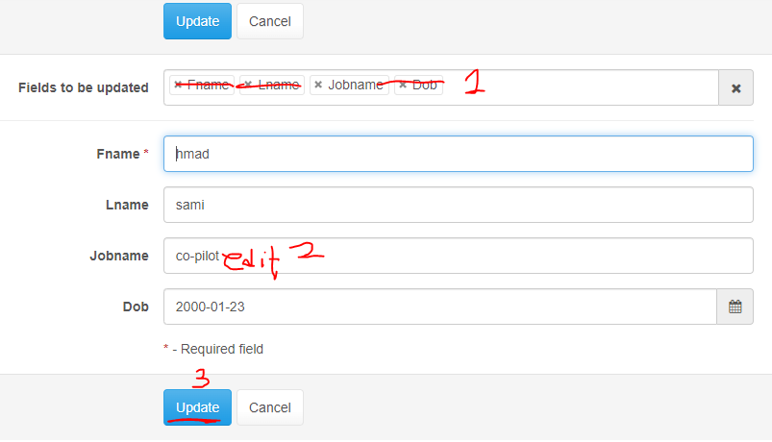

…………………………………………………..



If you press on traveller:

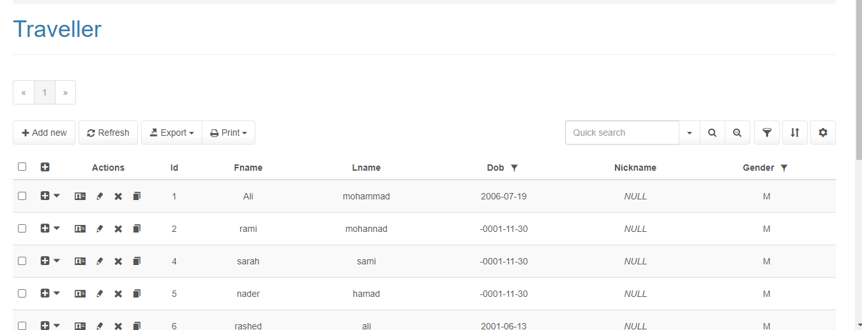

You can apply a filter:  
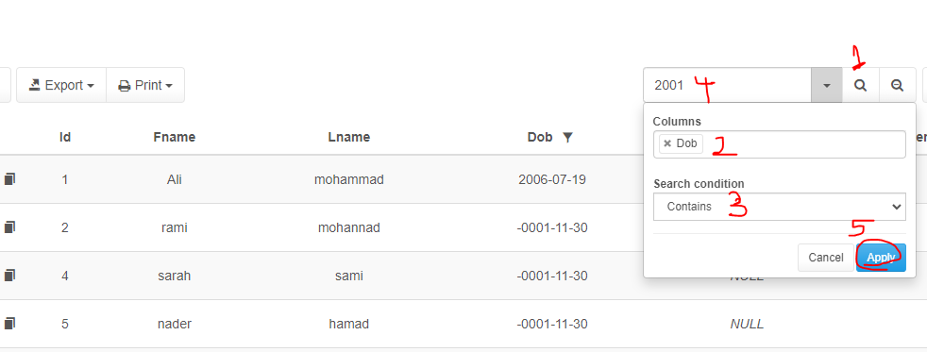

Or in the previous way.

To add a traveller:  
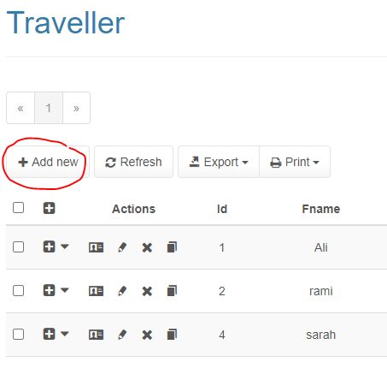

Then enter the info and save.

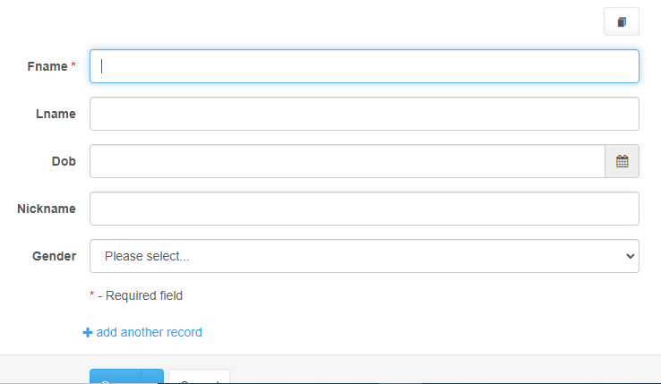

To edit a record:



Then you enter the info and save.

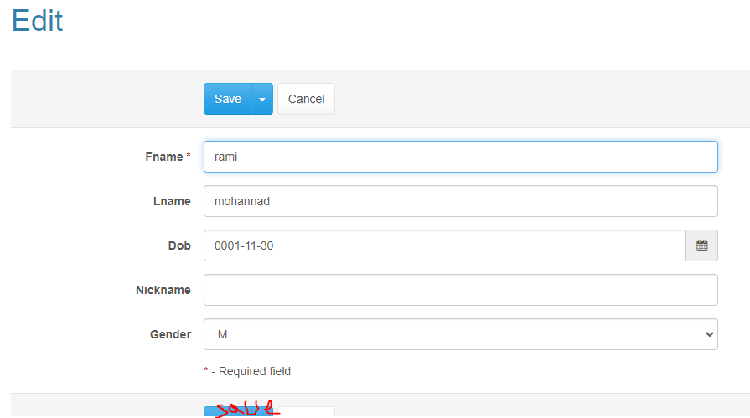

To delete:



_if you press on traveller phone number:

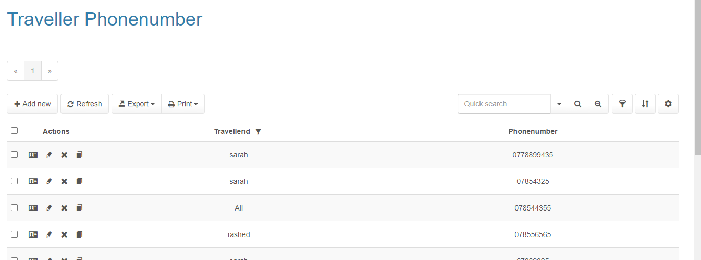

You can apply a filter by either previous ways :

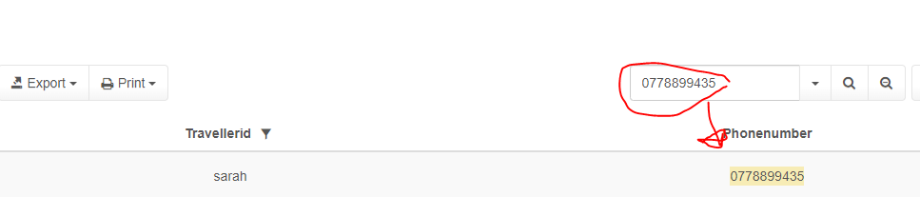

And you can add a phone number:

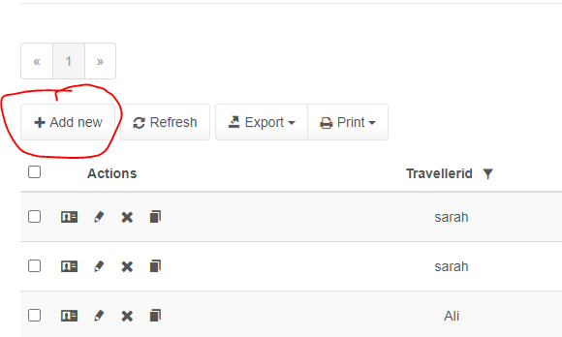

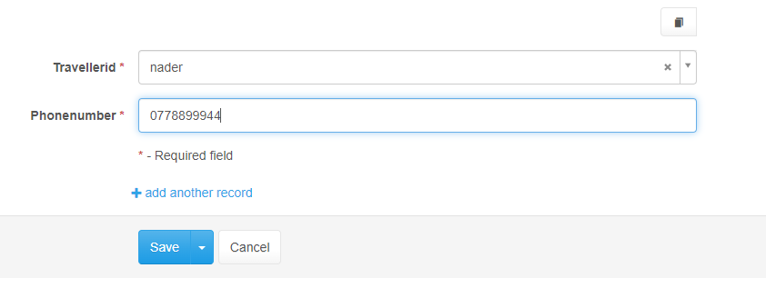

And then save:

If you entered bags Owners or number of jobs pages the user can only see the records and apply filters:

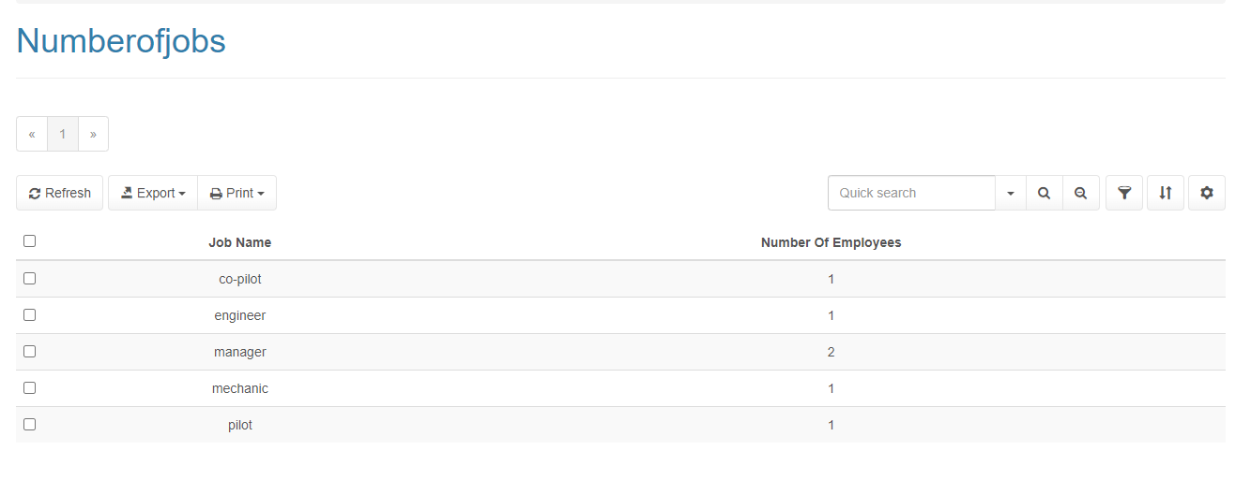

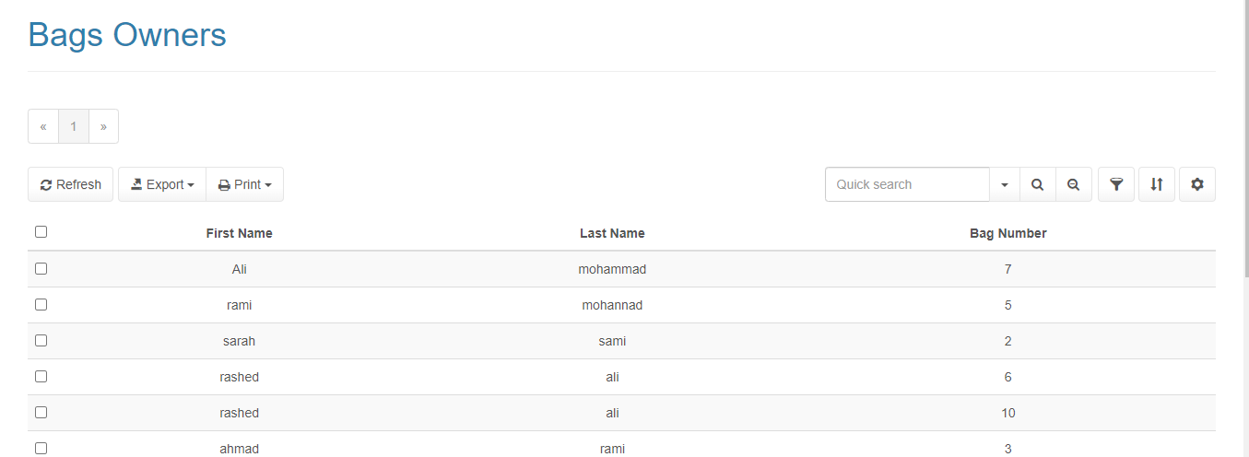

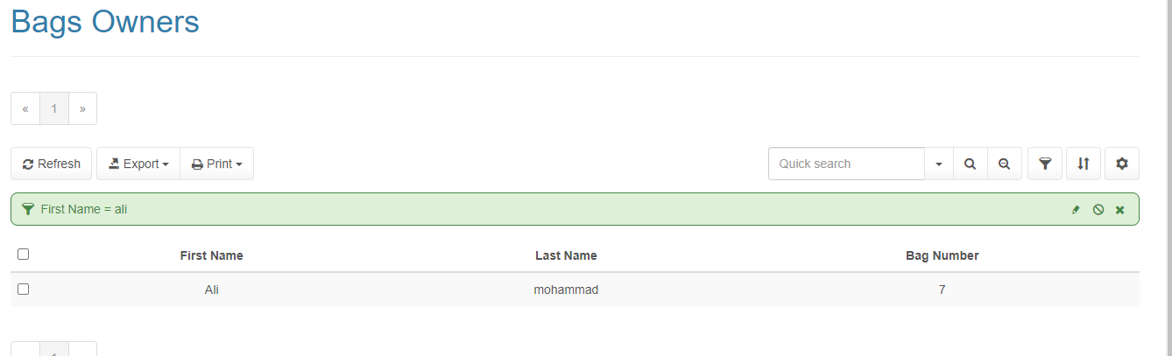

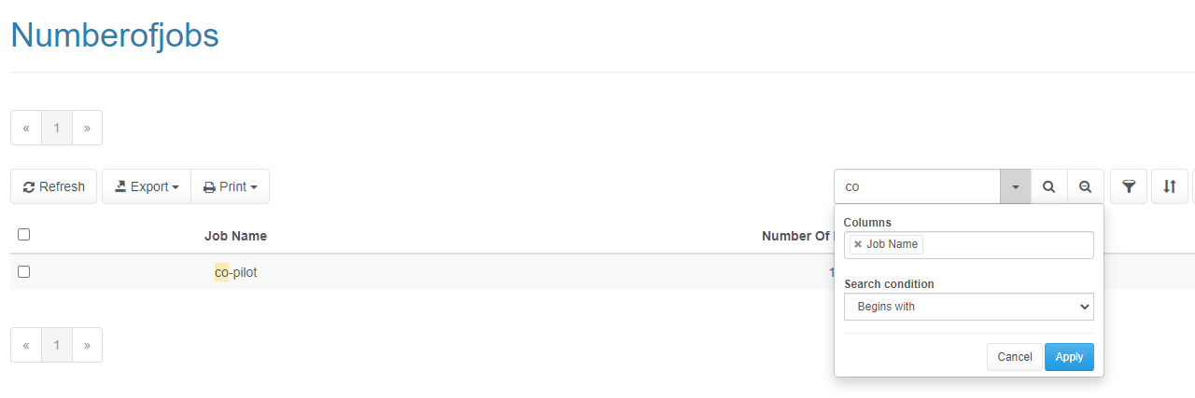

## Frequently asked questions

How can I get more privileges? Someone from the people how can configure the database can give you.

Do the things that the user does to the data directly get recorded to the database? Yes

If I only have the privilege to add or edit the data can’t I see it? If you don’t have the select you can see.

Can un authorised people see or change the data? On only authorised people can

## Contact information

Email:Abdallahsalhab2003@gmail.com

Phone number:0798561851